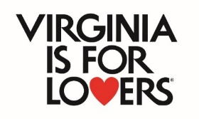

Spring 2024 VTC DMO Marketing Program
Application Template and Instructions
VTC has created this application template and instructions document to assist you in preparing your application. You can copy and paste your answers from this document into the required web portal. Applications will only be accepted via the online web portal and applications are due by 5 p.m. on Thursday, March 14, 2024.
We recommend that you also have the Spring 2024 VTC DMO Marketing Program Terms and Conditions document open and available as you fill out this application template. The Terms and Conditions document reviews applicant eligibility, eligible and ineligible expenses, and reimbursement processes. You can also review the reimbursement form and reimbursement instructions on www.vatc.org/grants.
These documents can help you understand which receipts, proofs of payment, invoices, and tear sheets you will need to submit to be reimbursed if you are awarded funding. Please read those documents before starting your application.
For your reference, marketing expenses are expenses related to marketing the event. Be sure to check the Terms and Conditions for what types of marketing expenses are eligible. This program has very strict requirements and you will not be reimbursed for ineligible expenses AND your award, if you qualify, may be reduced if ineligible expenses are listed in your match sections.
Once you completely submit your application you cannot edit it in the web portal. However, you can stop and start your application in the web portal by saving your application url. Do not click submit until you are absolutely sure you are ready to do so.
Please note attachments are not saved when you stop and start your application. If you are having trouble submitting your application, please double check that all your required attachments are uploaded in the portal with the corresponding question.
If you need technical assistance, you can use the Technical Assistance request box on the grant application web portal or you can contact VTCDMOGrant@virginia.org for assistance.

General Information Section
Only officially recognized DMOs as of 12/31/2023 are eligible for the Spring 2023 DMO Marketing Program.
Your destination must be listed on Virginia.org (the state tourism website) for reimbursement. This is a requirement. Please visit https://www.vatc.org/marketing/digital-marketing/webmarketing/ to set up an account or manage your destination listing.
An example Virginia.org url looks like this: https://www.virginia.org/listing/cape-charles/5128/
Is your destination/DMO listed on Virginia.org? | Yes/No
If yes, what is the url?

DMO Name:
# of full and part-time employees at the DMO:
Locality where DMO is located:
EIN#
DMO Contact Name:
DMO Contact Title:
DMO Contact Email:

If the applicant is a very small locality managed DMO, please list the County Manager or Finance Officer as the secondary contact. All other applicant types should include a secondary contact from within their organization or business.
Secondary DMO Contact Name:
Secondary DMO Contact Title:
Secondary DMO Contact Email:

The program is only open to Virginia DMOs. Non-Virginia DMOs, businesses, attractions, and museums may partner with a Virginia DMO lead on an application, but non-Virginia entities may not be the lead partner in VTC funding programs.
DMO Mailing Address:
DMO City, State, Zip:
DMO Phone:

The maximum award is $20,000. Applicants do not have to request the maximum award.
Amount of Requested Funds:

If you are planning to use these funds to market any concerts, events, meetings, or conventions outside the scope of normal operations then you will need to provide a liability insurance policy/certificate with Virginia Tourism Corporation listed as an interested party. If you do not yet have insurance coverage, you do not need to upload a policy. VTC will send you reminders to complete this step.
Are you planning to use these funds to market any events, concerts, meetings, or conventions outside the scope of your normal operations? | Yes/No
If, yes please upload insurance certificates if available.

Please list the DMOs social media handles, website, and hashtags where applicable.
Twitter:
Facebook:
Instagram
Website:
Hashtags:

Program Marketing Goals (15 points)
Please choose the best category that is the best fit for your marketing program.
Program Focus: | Choose One from drop down list:  Arts & Culture  Culinary/Craft Beverage/Wine  Equestrian  Luxury Travel  History  Music  Outdoor Recreation  Sports  LGBTQIA+  Holidays  General Destination Marketing

Please choose a creative name that reflects your marketing plan. Do not use an individual’s name and do not use the business/organization name. Indicate the dates of your marketing program being mindful of VTC’s lookback period and 18-month, from award date, program maximum. Our goal is to notify applicants of awards by mid-April 2024 hence the October 2025 program deadline. Think about how this marketing program can enhance your normal marketing activities, target new demographics, and promote accessibility.
Marketing Program Name:
Marketing Program Description:
Start Date of Marketing Program (can be no earlier than October 1, 2023)
End Date of Marketing Program (can be no later than October 1, 2025):
How will VTC funding enhance your normal marketing activities?
Will these funds enhance your marketing to diverse audiences or promote accessibility? | Yes/No
If yes, please explain.

Driving overnight visitation is a critical component of VTC programs. An overnight visitor is one who spend at least one night at or near the locality. A regional visitor is a day tripper who comes from at least 50 miles away. Explain how your marketing choices in this plan will help drive additional overnight visitation and additional out-of-region visitation. Be sure to reference research from your prior marketing campaigns, social media insights, and/or Virginia Tourism Corporation travel profiles that can be found on www.vatc.org/research.
Project the number of visitors that will come to your destination as a result of this marketing program. We understand that marketing conversation rates are not an exact science. However, your projected visitation will help us measure the economic impact of this program.
How will this program drive additional overnight or out-of-region visitation?
Projected # of out-of-state visitors from this marketing program:
Projected # of regional visitors coming for a day trip from this marketing program:
Total Projected # of visitors (out-of-state + out-of-region) from this marketing program:
What research did you use to validate these projections?

Competition (10 points)
What destination is your #1 out-of-state competition?
Why did you select this destination?
What destination is your #1 in-state competition?
Why did you select this destination?
How does your marketing plan make you more competitive against these destinations?

Hub & Spoke Section (15 points)
Virginia Tourism Corporation uses a Hub & Spoke itinerary and development model.
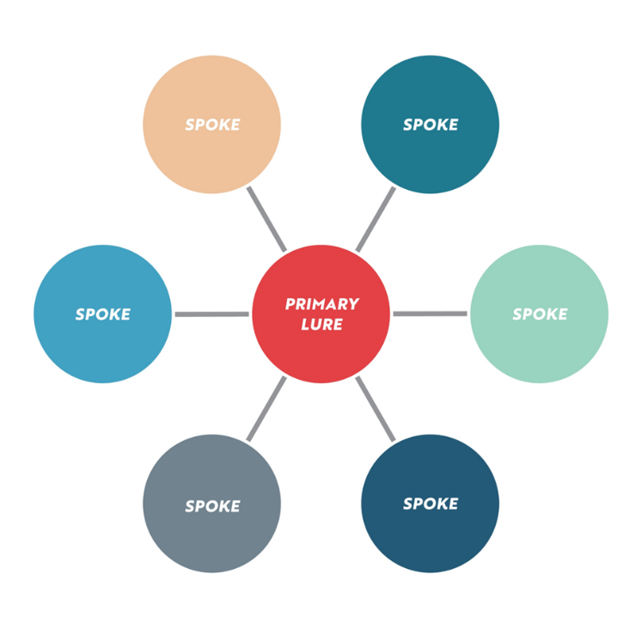
Your destination or a major attraction is the Primary Lure and the itinerary/partnership has six spokes. Two of those are partners in your marketing plan and four of those are spokes in your marketing plan. For this program, you need to identify your two partners and how they will support your marketing plan both financially and through their own marketing initiatives. And you will need to identify four additional spokes that are actual businesses, attractions, restaurants, lodging, etc that visitors may go to during a visit to your business or destination. You must use actual names of businesses in this section. Please do not list general categories such "restaurants." Instead, list exact names of businesses, such as Whistlestop Café or Joe's B&B.
LODGING PARTNER
PARTNER

New in 2024! One of your partners must be a lodging partner and you must upload a letter of support from that partner. We understand that there may be a lodging deficit in some rural localities. In that case, you may choose a regional lodging partner, state or national park, regional campground, etc. However, a letter of support is still needed.

What is the primary lure?
Lodging Partner Name:
Lodging Partner Address, City, State, Zip:
How will partner support your marketing program:
Is the partner listed on Virginia.org? | Yes/No
If yes, what is their Virginia.org url?
Upload Letter of Support from Lodging Partner:
Partner #2 Name:
Partner #2 Address, City, State, Zip:
How will partner support your marketing program:
Is the partner listed on Virginia.org?
If yes, what is their Virginia.org url?
Upload Letter of Support from Partner #2
Spoke #3
Spoke #4
Spoke #5
Spoke #6
How will these spokes support your marketing program?

Target Markets (20 points)
Your must choose at least TWO target markets, but you may choose THREE. Be sure to reference data from your social media insights, credit card processing data, other market research, and VTC research to justify why you selected those target markets. VTC visitor profile data and other research can be found at www.vatc.org/research. Applicants are encouraged to spend at least 25% of their requested amount on an out-of-state target market. The drop-down box selections are: Baltimore, MD; New York, NY; Philadelphia, PA; Raleigh, NC; Boston, MA; Cleveland, OH; Columbus, OH; Harrisburg, PA; Nashville, TN; Pittsburgh, PA; Atlanta, GA; Charlotte, NC; Chicago, IL; Washington D.C.; Hampton Roads; Richmond; Roanoke-Salem; Bristol; Charlottesville; Danville; Northern Virginia; Harrisonburg; Winchester; Fredericksburg; In-State Other, Out-of-State Other, International Other.
Target Market #1
Why did you choose this market?
Target Market #2
Why did you choose this market?
Target Marketing #3
Why did you choose this market?

Marketing Plans (30 points)
Your marketing plan is a critical component of your application. Please be sure to reference the Terms and Conditions of this program for a list of eligible and ineligible marketing expenses.
VTC recommends that you research the VTC Co-op Industry Advertising Plan that provides some discounts with certain publications. Information on those opportunities can be found at: https://vatc.org/marketing/advertising/partneradvertising/
You may also want to research advertising opportunities through the PMAP/Welcome Center program managed by VTC. You can find information on those opportunities here: www.welcomeva.com
Be sure to indicate the name of the vendor, such as Facebook/Meta or Instagram/Meta in your marketing plan. If you don’t know the name of the vendor, such as an event insurance policy underwriter, then please describe the vendor/business type in that column.

In-Kind or Cash Match Marketing Plan: This is your match. This grant requires a minimum of 50% cash or in-kind match. You may count your normal marketing expenses as match. You can also count owned and earned media as match. Owned and earned media have a lookback period to June 1, 2023. Cash/Paid marketing expenses have a lookback period to October 1, 2023. Please see below on how to value owned and earned media.
If you are asking VTC for $20,000 , you must have AT LEAST $10,000 in cash or in-kind match listed. We encourage you to list more than the minimum match, so we are better able to understand the economic impact of these programs. Applications with more than the minimum match will score higher.
Create your cash or in-kind match marketing plan by listing eligible marketing plan items. See the DMO Marketing Program Terms and Conditions for a list of eligible marketing plan items.
Each line items must list the media channel/vendor; marketing items description including target markets, target demographics, etc; placement dates; and amount.
The VTC scoring teams will be looking at how your marketing plan choices match up to your chosen target markets and target demographics. Make sure you are looking at your marketing funnel and that your have made deliberate choices backed up by data and research.
This program allows for both in-kind and cash match.
For cash match, simply list the vendor, items/target demographics if applicable, date, and projected dollar value
For in-kind marketing match, the following criteria applies:
Only eligible marketing expenses listed in the Terms and Conditions can be counted as in-kind marketing match. A summary of how to value earned and owned media is below but refer to the program Terms and Conditions for more information.
- In-kind marketing match based on owned and earned media can be calculated based on the following:
Print editorial $250/quarter page. $1,000 per full page. (Must have appeared in print after June 1, 2023.)
Online editorial $500/quarter page. $2,000 per full page. (Must still be hosted online.)
Print listing $100/each (Must have appeared in print after June 1, 2023.)
Online listing $200/each (Must still be hosted online.)
Social Media Followers 10 cents each
Owned media website clicks 10 cents each per link (Must be as of June 1, 2023.)
- In-kind marketing match should be listed in the In-Kind and Cash Match Marketing Plan as separate line items with detailed information about the articles, dates, social media channel, website, links, etc.
- Cash match should be calculated on the actual cost of the marketing activity.

For in-kind earned and owned media match, you can lookback to June 1, 2023. For in-kind cash/paid match, you can only lookback to October 1, 2023.
Cash or In-kind Match Marketing Plan Example:
Media Channel/Vendor | Marketing Items Description | Placement Dates | Amount
Example: Facebook/Meta | 200,000 followers as of June 1, 2023 | As indicated by Facebook Insights on June 1, 2023 | $2000.00
Example:  Washington Post (earned media) | Full page editorial in Travel section in October 2023 featuring the wine festival and things to do in Our Town, Va. Using ad equivalency value full page = $8,000 | October 25, 2023 | $8,000
Event Insurance/Vendor TBD | Event insurance coverage for the weekend of November 4-6, 2024 | Policy in effect November 4-6, 2024 | $800
 |  | Total In-Kind Marketing Match: | $10,800

Add lines as needed to your marketing plan until you have allocated your match. You are encouraged to include more than the minimum match. Please double check your totals as you tab through creating your marketing plan.

VTC Reimbursement Marketing Plan: These are items for which you will be seeking VTC reimbursement. The total of your VTC Reimbursable Marketing Plan should at least equal your requested award amount. Be sure to list only eligible expenses from the program Terms and Conditions. You will only be reimbursed up to your award amount. Partial awards may be made, and applicants must be willing to revise their marketing plans.
VTC Reimbursable Marketing Plan Example:
Medic Channel/Vendor | Marketing Items Description | Placement Dates | Amount
Example: Charlotte Observer | Quarterly Print Ads in the Travel section; 4”x7”; targeting wine enthusiasts ages 25-64 who are interested in wine festivals who live in the Charlotte, NC area and who read the Charlotte Observer | Jan 2024  April 2024  July 2024  October 2024  $3000/each placement | $12,000
Example: The Image Group | Promotional items for staff during wine festival to included 20 T-shirts and one pull-up banner with Virginia is for Wine Lovers. Event marketing is targeting wine enthusiasts ages 25-64 who will see the banner and logo shirts on site. | July 2024 | $2,000
 |  | Total VTC Reimbursable Marketing Plan | $14,000

Add lines as needed to your VTC Reimbursable Marketing Plan until you have allocated the full amount of your funding request. The maximum award is $20,000 for this program. Please double check your totals as you tab through creating your VTC Reimbursable Marketing Plan.
Make sure you are not going over the maximum 10% of requested award allowance for insurance, music licensing fees, A/V rentals, or promotional items. More information about the maximum 10% of award allowance for certain marketing expenses can be found in the program Terms and Conditions document.
Make sure your VTC Reimbursable Marketing Plan total matches up with your requested amount at the beginning of the application.
Performance Outcomes (10 points)
Your must select two performance outcomes from the drop-down box. Sources of data upon which to base your projected measures can be visitor logs, credit card data, ticket sales, overall sales, tax revenue, etc. Set reasonable baselines and goals. Increases of 3%-5% are reasonable.
Performance Outcome #1 | Select from Drop Down Box  # of Room Nights  # of Customers/Visitors  $ Annual Sales  # of Visitors  # of Event Attendees | Performance Baseline | Performance Baseline Date | Performance Projection (Goal) | Performance Projection (Date)
Performance Outcome #2
Example | Room Nights | 1500 | 06/01/2023 | 1575 | 06/01/2025

Bonus Section (5 points)
This section allows for you to get creative. Think about ways you could activate the Virginia is for Lovers brand at your destination, business, or event. Are there special opportunities or behind-the-scenes opportunities you could offer to journalists, reporters, photographers, and videographers? Be detailed in your descriptions and dates. Including opportunities in this section does not guarantee that VTC can provide staff or journalists to take advantage of those opportunities.
Select from Drop Down Box  Press Passes or Tickets to Events  Booth at Event  Visitor Center has Virginia is for Lovers merchandise  Photography Opportunity  VIFL Banners at events, visitor centers  VIFL apparel on staff/performers  Unique "behind the scenes" opportunity  Comp or Discount Lodging for Photography or Video Acquisition  Recognition of VTC as a sponsor at events  Other | Describe the activation: | Dates of activation:

