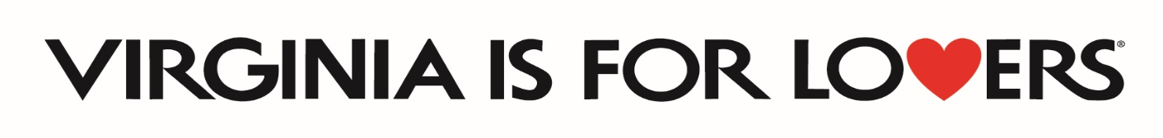
2024 Marketing Leverage Grant
Frequently Asked Questions
(Updated as of 01/18/2024)

Q. The application deadline is tomorrow, and I don’t have time to set up my Virginia.org account and listings. Can I still apply?
A. Yes. However, you must set up your account and update your listing before you can receive any reimbursements. We recommend that you complete your listing as soon as possible to maximize your marketing potential.

Q. If I am applying to the Marketing Leverage Program for a special event or festival do I need two years of attendance data like the Special Events and Festival Program requires?
A. No. The two years of attendance data requirement is unique to the Special Events and Festival Program.

Q. Can a DMO apply for Marketing Leverage Program if they are applying for the DMO Marketing Program?
A. Yes. DMOs can apply for the DMO Marketing program, the Marketing Leverage Program, and the Special Events and Festivals program.

Q. Is the Marketing Leverage Program just for events?
A. No. It is mainly for general marketing to drive visitation to your business, attraction, or destination.

Q. Is a regional airport eligible for the Marketing Leverage Program?
A. Yes.

Q. What is the match requirement for this program?
A. Because we are out of “recovery” mode, this program now requires a 1:1 CASH match like the program requirements pre-pandemic.

Q. In previous years, the $20,000 award tier required 2:1 match of $40,000. How come it changed to a 1:1 match?
A. VTC recognizes that many businesses are still recovering
Q. Are hotels eligible for this program?
A. Yes.

Q. Where can I find out how to contact our local DMO?
A. A list of those DMOs can be found at: https://www.vatc.org/business-directory/wpbdp_category/dmo/

Q. I am still working on completing the deliverables for a prior Recovery Marketing Leverage Program round. Can I still apply?
A. Yes, but your program deliverables must be new items/placement dates and not duplicates from your prior application.

Q. Which one of the official Virginia is for Lovers logos do I use?
A. You can find a list of the official versions of the Virginia is for Lovers logo and request those logos in various formats at this link: https://vatc.org/marketing/advertising/vifl-logo-request/

Q. Is the 10% allowance for promotional items only for Virginia is for Lovers branded items?
A. No. You may use up to 10% of your award for any type of promotional items. However, if you are interested in Virginia is for Lovers items, they must be order via the Image Group. You can find information on how to set up a wholesale account at www.thevastore.com.
Q. If we offer free tickets, lodging or other opportunities for VTC staff or journalists to cover our business or event will I be guaranteed some news articles or blogs?
A. No. VTC is unable to guarantee that VTC staff or journalists will be able to use those tickets or opportunities to cover the event. However, should we be able to use that activation that you listed we will contact you for details and let you know who will be attending.
Q. Can some of the VTC funds be used to create/improve accessibility to our program? Will it be reimbursable?
A. Yes, VTC funds can be used to create/improve accessibility, and it will be reimbursable. (For example: you could use funds to pay for website upgrades that improve accessibility of your website)
Q. Can our match include items like event insurance/promotional items? And if so, does that still need to be 10% of the budget or is the 10% only applying to if we are requesting those funds?
A. The 10% allowance on certain items also applies to the match side. So, on those items that you are paying for and not requesting VTC reimbursements, you could only count 10% of your insurance premium as match; 10% of the promo items as match; 10% of the ASCAP/BMI fees as match, etc.
Q. Do partners or spokes need to make a budget contribution to the marketing plan or reach a minimum budget contribution?
A. Partners and spokes do not need to make a budget contribution to the marketing plan. They also do not need to reach a minimum budget contribution. Partners and spokes should be listed by name, and details should be provided on how they will support your program.

