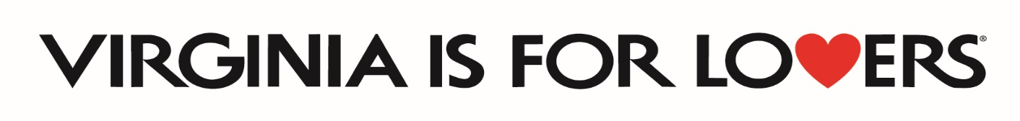
2023 DMO Marketing Grant
Frequently Asked Questions
(Updated as of 01/18/2024)

Q. The application deadline is tomorrow, and I don’t have time to set up my Virginia.org account and listings. Can I still apply?
A. Yes. However, you must set up your account and update your listing before you can receive any reimbursements. We recommend that you complete your listing as soon as possible to maximize your marketing potential.
Q. What if your county does not have a meals tax?
A. Then please indicate that in your projected metrics narrative section.

Q. If I am applying to the DMO Program for a special event or festival, do I need two years of attendance data like the Special Events and Festival Program requires?
A. No. The two years of attendance data requirement is unique to the Special Events and Festival Program.

Q. Can a DMO apply for the Marketing Leverage Program if they are applying for the DMO Marketing Program?
A. Yes. DMOs can apply for the DMO Marketing program, the Marketing Leverage Program, and the Special Events and Festivals program.

Q. Can room nights in the Performance Outcomes Section be estimated from lodging tax revenue?
A. Yes.

Q. What is the match requirement for this program?
A. At least a 50% cash or in-kind match is required.

Q. Our town is applying for recognized DMO status. All the paperwork should be done before the program award date of April 15. Can we apply?
A. No. Only DMOs officially recognized by December 31, 2023 are eligible.

Q. Which one of the official Virginia is for Lovers logos do I use?
A. You can find a list of the official versions of the Virginia is for Lovers logo and request those logos in various formats at this link: https://vatc.org/marketing/advertising/vifl-logo-request/

Q. Is the 10% allowance for promotional items only for Virginia is for Lovers branded items?
A. No. You may use up to 10% of your award for any type of promotional items. However, if you are interested in Virginia is for Lovers items, they must be order via the Image Group. You can find information on how to set up a wholesale account at www.thevastore.com.

Q. Can our match include items like event insurance/promotional items? And if so, does that still need to be 10% of the budget or is the 10% only applying to if we are requesting those funds?
A. The 10% allowance on certain items also applies to the match side. So, on those items that you are paying for and not requesting VTC reimbursements, you could only count 10% of your insurance premium as match; 10% of the promo items as match; 10% of the ASCAP/BMI fees as match, etc.

