This Word Document contains the questions and information within the online application for the VTC DMO WanderLOVE Program. The document allows you to see the entire questions of the application. You may want to enter your answers in the Word Document, then copy and paste into the online application.
NOTE: ONLY ONLINE APPLICATIONS WILL BE ACCEPTED.

VTC DMO WanderLove Grant Program
VTC is pleased to announce that applications are now open for the Virginia Tourism Corporation (VTC) DMO Recovery Grants. The grants are designed to provide immediate recovery marketing funds to destination marketing organizations (DMO) across the Commonwealth that have been heavily impacted by the novel coronavirus pandemic. VTC will provide up to 50 grants to DMOs in the amount of up to $10,000 each.
This program is open to only recognized Virginia DMOs.
Overview:
The coronavirus has had a devastating impact on the tourism and hospitality industries in Virginia. As the Commonwealth slowly reopens for business, Virginia Tourism is offering these grant funds as a first step to re-entry into the marketplace to spur economic activity and travel across the Commonwealth.
Based on industry research, in-state and drive-market road trips will be the first to return as restrictions are lifted in Virginia and across the country. Travelers will be seeking safe, close-to-home destinations that allow for social distancing and access to open spaces, specifically beach, outdoor and rural experiences. Additionally, 40 percent of Americans intend to take a road trip this year.
In response, VTC has created a new integrated summer campaign, WanderLove, that will provide travel inspiration for epic Virginia Road Trips. The campaign will feature outdoor recreation, hidden gems, small towns, and VTC’s signature LOVEworks program. This grant will provide DMO partners a simple and flexible way to participate in the WanderLove program. Each recipient will be equipped with creative templates and resources to highlight their own destination.
WanderLove Partner Requirements:
VTC is offering a grant of $10,000 that can be used on anything related to the WanderLove campaign, but there are a few requirements.
Check out the Partner Requirements.
Read the VTC DMO WanderLove Grant Terms & Conditions. The Terms & Conditions contain information on allowable expenses under the VTC DMO WanderLove Grant.
Download the VTC DMO WanderLove Grant Word Document so that you can see the questions to answer in the application. (You may want to complete the narrative sections, and then cut and paste into the online application).

On the form below, please complete:
Contact Information
Completion Date
Road Trip Hub & Spoke
Feeder Markets
In- Kind Match
Marketing Plan
Virginia is for Lovers “WanderLove” Campaign Tie-in
VTC DMO WanderLove Grant Application
Please note that your information is saved on our server as you enter it. If you leave the application, you will receive a unique URL that will allow you to go back into the application to make edits. Once you are ready to submit the final version, you will acknowledge the Acceptance of Terms. A SUBMIT button will appear. At that point you may submit your application for review. Please note that once you submit, you will NOT be able to make any revisions to your application.
DEADLINE INFORMATION:
Applications open June 18, 2020
Applications close July 2, 2020; no extensions will be possible.
Award announcements by July 15, 2020

Contact Information
DMO (Choose from drop down menu on online application)
FEI#
Contact First Name
Contact
Last Name
Mailing Address
Street Address
City
State
Zip Code
Phone
Email

Anticipated Date of Completion

WanderLOVE Hub and Spoke
The WanderLove campaign will focus on promoting Road Trips around Virginia. We want our DMO partners to join these efforts by creating fun and unique road trips that will highlight your own destination.
The Hub and Spoke model is the perfect tool for planning out an itinerary. Use the template below to build a road trip in your destination that highlights fun and unexpected experiences for visitors. Start by thinking about your destination as the “Hub” and listing out different experiences for visitors to drive to in the “Spokes”.
Helpful Hints-
Road trips are all about the journey and the- sometimes- unexpected stops along the way. Think about some unexpected and “hidden gems” in your destination that travelers will enjoy.
Themed itineraries are a great way to highlight the best of what your destination has to offer. If your destination is an outdoor-lovers haven, create a road trip that will cater to the outdoor enthusiasts!
Partners are not required with this grant but they could be included to make your road trip even stronger! Think about ways to include other destinations or major attractions that could make a great partner for your campaign.

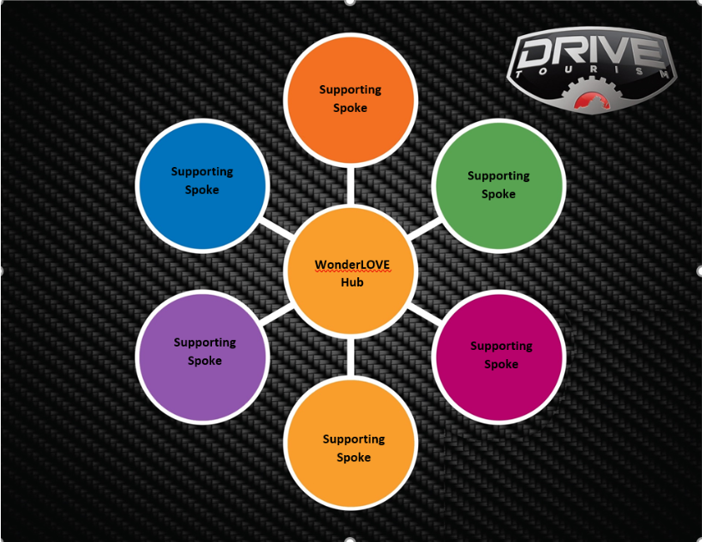

WHAT IS YOUR STRONGEST LURE? YOUR HUB.* This will be your Road Trip Hub.
- HUB
WHAT ARE YOUR SIX SUPPORTING SPOKES?
- Spoke
- Spoke
- Spoke
- Spoke
- Spoke
- Spoke
Top Three Feeder Markets
Who is most likely to visit your destination on a road trip? Who would you like to visit? Tell us briefly who your campaign will reach by including your top three feeder markets.
- Feeder Market
- Feeder Market
- Feeder Market
Your In-Kind Match
For the WanderLove Grant, you do NOT need a cash match. However, we do require an in-kind match. Please briefly describe your in-kind match for these funds. Your in-kind match can include the estimated value of your owned and earned media; value of current ad placements, etc.

Description of You In-Kind Match

Estimated Value of In-Kind Match

Marketing Plan, Calendar and Budget Amounts
Your marketing plan will help bring your idea to life. In this section, we want to hear how you will promote your WanderLove campaign through strategic marketing efforts. Show us an integrated approach to promoting your campaign by thinking about the best places to amplify your message and reach your intended audiences. Please list specific media placements, date of placement and cost. Be as detailed as possible.

Helpful Hints:
Remember the Partner Requirements as you develop your Marketing Plan
VTC’s Co-op program can be used with this grant. Check out the Program Recommendations as you develop your Marketing Plan
Detailed information about the WanderLove campaign can be found at www.vatc.org/wanderlove-campaign

Marketing Plan Target Date Budget
You may continue to add items to your Marketing Plan, as needed

Virginia is for Lovers “WanderLove” Campaign Tie-in
In addition to the Partner Requirements, tell us how you will further promote WanderLove. Be creative with your ideas and think of other ways to bring your campaign to life! This section will be scored based upon well thought-out ideas and the creativity. Refer back to the Partner Requirements.
Detail additional ways beyond the required WanderLOVE components that you will incorporate WanderLOVE in your local program.
DEADLINE INFORMATION:

- Applications open June 18, 2020
- Applications close July 2, 2020
- Award announcements by July 15, 2020

Please note that your information is saved on our server as you enter it. If you leave the application, you will receive a unique URL that will allow you to go back into the application to make edits. Once you are ready to submit the final version, you will acknowledge the Acceptance of Terms below. A SUBMIT button will appear. At that point you may submit your application for review. Please note that once you submit, you will NOT be able to make any revisions to your application.

