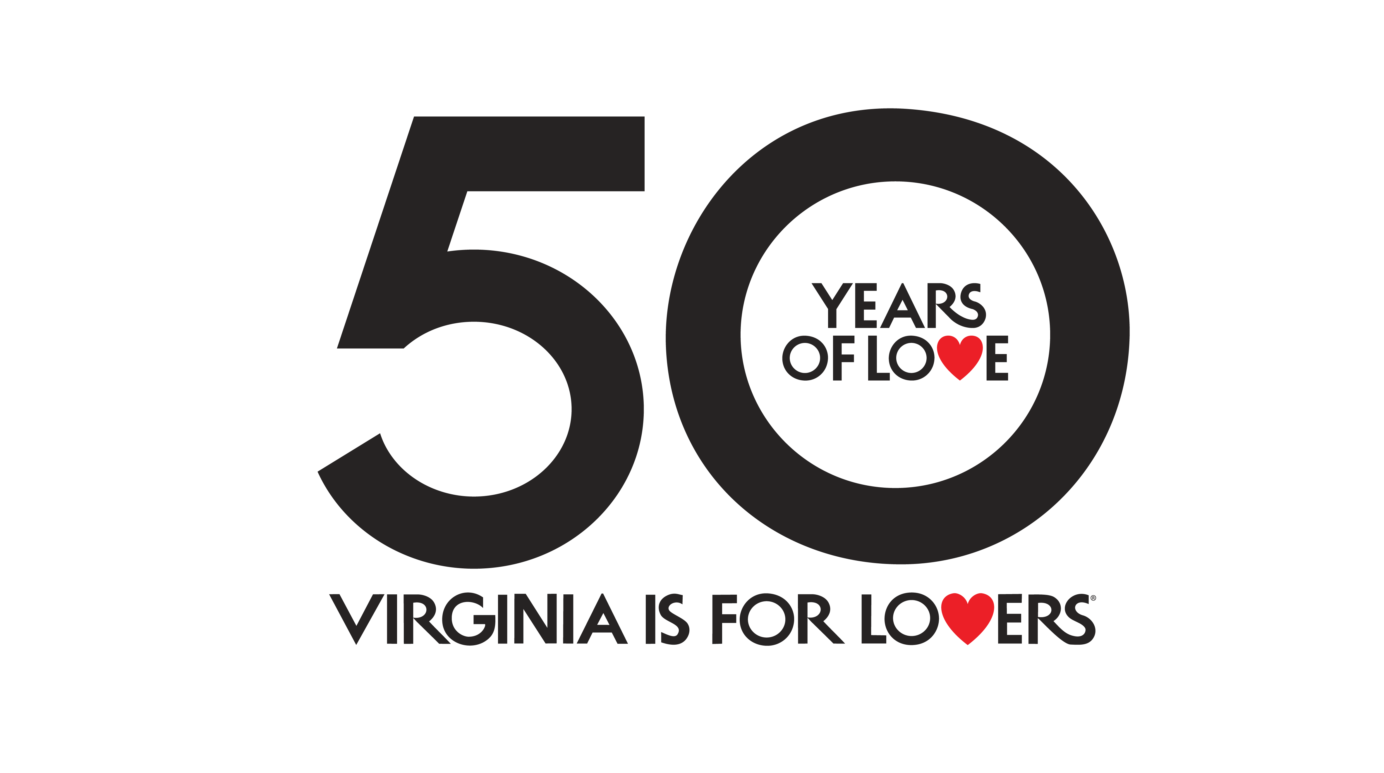
GRANT APPLICATION

50 YEARS OF LOVE
Virginia is For Lovers was established in 1969, 50 years ago, and has become one of the most beloved and well-known slogans in the world. While it has meant a lot of different things to a lot of different people, one thing has never changed – the love.

In 2019, we’re celebrating 50 years of love with special experiences across the state. We invite you to participate by developing local activations that will last 50 days.

The 50 Years of Love grant is open only to recognized Virginia Destination Marketing Organizations (DMO).

Ideally, each DMO will engage as many local businesses as possible, take our 50 YEARS OF LOVE ideas and blow them out of the water. VTC will help promote what you are doing to bring even more eyes to all of the amazing things that will take place in 2019 only in Virginia.

A VTC-led activation will take place during the summer of 2019, kicking off the first day of summer – Friday, June 21 – and ending 50 days later, Saturday, August 10, 2019. Your DMO-led activation(s) can take place during the same timeframe (June 21 to Aug 10) or you can select a start and end date of your own. We just ask that no matter when in 2019 you launch your campaign that is lasts for 50 consecutive days.
MONEY TO HELP spread the love
VTC and The Martin Agency developed ways to get you and your local businesses involved. These activations will only be available in Virginia for a certain time period in 2019, which will attract travelers to Virginia and your locality.

VTC is offering a $10,000 grant that can be used on anything related to the 50 YEARS OF LOVE campaign. There are seven elements that are mandatory and must be included, and three elements that are optional but will count for additional points in your application’s evaluation.

Mandatory elements (refer to Section Two for detailed descriptions):
- Follow branding guidelines available on vatc.org/50YEARSOFLOVE and include 50 YEARS OF LOVE logo on all creative.
- Choose an approved partner activation or create your own. Visit vatc.org/50yearsoflove to see all partner activations available. You can select one or create something unique that better fits your locality.
- Use VTC’s TV commercial/video (or create your own using the 50 YEARS OF LOVE branding) to promote what you are doing for 50 YEARS OF LOVE. (:30 TV commercial/video will be delivered to all partners on grant award date). Post the commercial/video on your website, online or social media.
- Engage 10 or more businesses in your locality that will all take part in the 50 YEARS OF LOVE campaign. Preference given to events and programs that live on after 2019. Ex: A mobile LOVEwork that will travel around your destination for 50 days that can then be displayed in your locality as a permanent LOVEwork.
- In addition to sharing the commercial/video on social media, post a minimum of three 50 YEARS OF LOVE related posts per month on social media using customizable social media assets provided by VTC.
- Submit a press release to relevant media outlets promoting what is happening in your locality for 50 YEARS OF LOVE.
- Share photo and video assets captured for 50 YEARS OF LOVE promotions with VTC including full usage rights in perpetuity.

Optional elements – EXTRA POINTS:
- Include out-of-state targeting when promoting what is happening in your area (10 points)
- Partner with a regional/DMO, national or well-known brand or established influencer(s) that will cross-promote the activation statewide or out-of-state. (5 points)
- This is where we look for your creativity. Beyond what has already been requested, what ideas do you have for a local campaign or promotion for 50 YEARS OF LOVE? (5 points)
50 YEARS OF LOVE grant awards are a maximum of $10,000. 30 DMO partners will be awarded $10,000 each.
Please make sure your application completely answers the required questions, and be creative. Funds will be awarded upon application approval and signing of Letter of Agreement with VTC.
WHO CAN APPLY?
50 YEARS OF LOVE grants are open only to recognized Virginia Destination Marketing Organizations (DMO). A list of recognized Virginia DMOs is available at https://www.vatc.org/dmo-ctic-lists/wpbdp_category/dmo/.
50 YEARS OF LOVE Grant Application Scoring
Applications will be scored based upon the following criteria:
- Is the contact form complete and the acknowledgment section signed? (10%)
- Are all seven 50 YEARS OF LOVE “Mandatory” items included with a brief description of each of the items? (35%)
- How effective are the additional ways you will promote 50 YEARS OF LOVE? How creative are your 50 YEARS OF LOVE ideas? (30%)
- How effective and complete is your 50 YEARS OF LOVE budget? (25%)
HOW TO APPLY!
Applications are now open and available at www.vatc.org/50YEARSOFLOVE. Download the application, provide the required information, and return to VTC no later than 5:00 PM on Tuesday, January 15, 2019. Awards should be announced by Thursday, February 14, 2019.
Read the instructions on the following pages to complete your application. NOTE: You will have limited space to answer the questions, so be concise!
For questions regarding 50 YEARS OF LOVE, please contact Shannon Johnson at 804-545-5567 or sjohnson@virginia.org.

Section One – 50 YEARS OF LOVE Contact Information
- Thoroughly complete the Contact Information section below, including your Federal Employer Identification Number.
- Sign the Contact Information Sheet indicating acknowledgment of requirement to sign a VTC Letter of Agreement, prior to receiving funds. Funds will be awarded up front, within 30 days of VTC receipt of signed VTC Letter of Agreement.
- Acknowledge that you agree to provide to VTC a short summary of the outcomes of your 50 YEARS OF LOVE efforts within 60 days of your campaign completion.
DMO NAME

Primary DMO Contact
Title

Mailing Address

 | City |  | State |  | Zip
Physical Address

 | City |  | State |  | Zip
Phone

Email

Website

Federal Employer Identification Number

Authorization for Application
I hereby certify I am authorized to sign this application requesting funding from the Virginia Tourism Corporation (VTC). I acknowledge that upon successful approval of the VTC 50 YEARS OF LOVE Grant application – and before receiving funding payment – that I, as DMO designee, will be required to sign a VTC Letter of Agreement confirming our DMO’s participation in 50 YEARS OF LOVE, and confirming remedies if – for whatever reason – 50 YEARS OF LOVE elements or benefits are not delivered to VTC. I also acknowledge that I will provide a short summary of the outcomes of our 50 YEARS OF LOVE campaign within 30 days of campaign completion.

_____________________________________________
Authorized Signature and Title Date

Section Two – 50 YEARS OF LOVE MANDATORY ITEMS
- Use 50 YEARS OF LOVE Toolkit and Logo
This one is easy! Visit vatc.org/50YEARSOFLOVE to find all of the partner activations available to you, including logos and how and where to use them, and photo and video usage language. Available Monday, November 26, you’ll have access to a toolkit that includes all you’ll need to develop your activation(s) (ad samples, social media creative, ad copy, press release template, etc.). So simply follow the guidelines on vact.org/50YEARSOFLOVE and use the toolkit and when developing your activation(s).

- Choose at least one approved partner activation or create your own
Choose from one or more of the partner activations or create your own. Selecting one? Tell us what you select, where it will take place, the start date and end date (50 days from launch). Creating your own? Give a brief description of the idea, the partners involved, where it will take place, start and end date. Please answer below, not to exceed one page in length for this item.

- Promote 50 YEARS OF LOVE video on web and social
1 – Tell us if you will use the :30 commercial/video we provide or if you will be creating a :30 commercial/video of your own. 2 - Tell us where the video will be featured on your website and how you will promote the 50 YEARS OF LOVE video on your website. 3 – Tell us where on social media it will be posted and whether the social media post(s) will be organic or have paid support. If paid, how much will you be spending on the video post(s). Please answer below, not to exceed one page in length for this item.

- Engage 10 or more businesses in your locality
Work with a minimum of 10 businesses/partners that will participate in the 50 YEARS OF LOVE Campaign in your area – wineries, breweries, hotels, small businesses, festivals, artisans, you name it – the sky is the limit! Businesses/partners should post about 50 YEARS OF LOVE on their website and social media channels. Tell us who your partners are, why you chose them and how they will promote 50 YEARS OF LOVE. Please answer below, not to exceed one page.

- Share minimum of three social media posts per month
In addition to posting the commercial/video on social media,tell us your social media strategy for promoting 50 YEARS OF LOVE on your social media channels. Include the social media outlet, frequency, messaging, call to action, budget, etc. In addition to promoting your activation, you must promote 50 YEARS OF LOVE at least three times monthly during May and June with a link to Virginia.org. Please answer below, not to exceed one page in length for this item.

- Submit a press release to relevant media
A sample 50 YEARS OF LOVE press release template will be available following your award notification at www.vatc.org/50YEARSOFLOVE. You must use this template to promote your 50 YEARS OF LOVE efforts. Tell us what media outlet(s) the release will be sent to, how many releases will be distributed and timing for distribution. Please answer below, not to exceed one page in length for this item.

- Share photo and video assets with VTC
Using DMO assets and what VTC captures in 2019, VTC will create content and posts to promote 50 YEARS OF LOVE and all that is happening across the state so your photo and video assets are important to us. Language for usage rights are included on www.vatc.org/50YEARSOFLOVE. Tell us what assets you will capture for your campaign (photo, video or both) and timing of when you will be sending us the files. Please answer below, not to exceed one page in length for this item age in length for this item.

Section Three – 50 YEARS OF LOVE Extra Points
Now is your chance to get 50 YEARS OF LOVE Extra Points! In addition to the seven Mandatory Elements, how will you further promote 50 YEARS OF LOVE?
Some examples we’ve included are:
- Include out-of-state targeting and receive an extra 10 points
- Partner with a regional/DMO, national/well-known brand or established influencer that will agree to cross-promote
- Be creative! Think of other ways you can bring 50 YEARS OF LOVE to life in your locality. This section will be scored based upon well thought-out ideas and the creativity.
Include in the 50 YEARS OF LOVE Budget Section (Section Four) any costs associated with your plans. Please answer below, not to exceed one page in length for this item.

Section Four – Your 50 YEARS OF LOVE Marketing Plan and Budget
In this section, please detail the costs associated with your 50 YEARS OF LOVE program. Include specific media – with placement dates, costs, etc. Also, include details and budgets for any 50 YEARS OF LOVE Extra Points activities. You may make changes to this plan as your program progresses, upon approval by VTC of the changes. You may add rows as needed to this table. Please be specific with detail on placements and specific dates.

50 YEARS OF LOVE PAID MEDIA AND MARKETING CALENDAR AND BUDGET
Media Outlet |  | Type, Size, and Frequency | Placement Date | Total Cost | Budgeted Amount | NOTES
OTHER PROJECT-RELATED BUDGET ITEMS
Specific Item (ad design services, 50 YEARS OF LOVE event costs, website design, etc.) |  |  | Anticipated Completion Date | Total Cost | Budgeted Amount | NOTES
TOTAL BUDGETED AMOUNT

How to submit your 50 YEARS OF LOVE application
The application MUST be received by the Virginia Tourism Corporation no later than 5:00 PM on Tuesday, January 15, 2019! THIS IS NOT A POSTMARK DATE.
Provide the original and four copies of your application. Staple the application in the upper left-hand corner. Do NOT attach any materials – such as brochures, etc. – to the application.
FAX and email applications will NOT be accepted. For tracking purposes and date/time delivery recording purposes, it is suggested that applications be sent via UPS, FedEx, DHL, or USPS Registered Mail/Return Receipt Requested.

Print the original, sign, and include FOUR COPIES of your completed application and mail to:
Leah Harms
Virginia Tourism Corporation
901 East Cary Street, Suite 900
Richmond, VA 23219

Awards should be announced by Thursday, February 14, 2019. Funds will be available within 30 days of receipt of the signed VTC Letter of Agreement.

Questions about the 50 YEARS OF LOVE Program and 50 YEARS OF LOVE Grant should be addressed to Shannon Johnson at 804-545-5567 or sjohnson@virginia.org.

